Design Critique Report
On
XDA Developers
https://www.xda-developers.com/

by
Derek Wang

ITIS-3130-051
Human-Centered Design
Dr. Sarah Abdellahi
February 25, 2023

Table of Contents
Overview 5
Visual Design 7
Grid Alignment 7
Typeface and Emphasis 9
Visual Design Critique and Improvement 10
Interaction Types and Modalities 10
Interaction Types and Modalities Critique and Improvement 12
Affordances, Signifiers and Gulfs 13
Affordances and Signifiers 14
Affordances and Signifiers Table 14
Gulf of Execution and Evaluation 14
Gulf of Execution and Evaluation Table 15
Affordances, Signifiers, and Gulfs Critique and Improvement 15
Heuristic Evaluation 15
Heuristic Evaluation Table 15
Analysis 16
Heuristic Evaluation Critique & Improvement 16
Conclusion 16

Figure 1: (Navigation Bar)
Figure 2: (News)
Figure 3: (Topics)
Figure 4: (Best Guides)
Figure 5: (More - DropDown)
Figure 6: (XDA Forums)
Figure 7: (Mobile Review)
Figure 8: (Latest News)
Figure 9: Screenshot without grid to show white space
Figure 10: Screenshot with lines and labels showing the grid, columns,and broken grid.
Figure 11: Another screenshot showing the grid, columns,and broken grid
Figure 12: Both Title and body uses sans serif fonts
Figure 13: Color
Figure 14: Interaction Types and Modalities
Figure 15: Interaction Types and Modalities 2
Figure 16: Modalities
Figure 17: Affordances and Signifiers
Figure 18: Affordances and Signifiers 2

Overview
XDA Developers is a News/Review/Forum website that is focused on Mobile and Computing Devices like Android(Phone & Tablet), Apple(Phone, Tablet, & Mac), Smartwatches, Windows, ChromeOS. On the XDA website, one can look for the latest news on mobile, computing, & deals, view reviews on mobile, computing, & smart home, search the news page by topic, view the best guides for current year which are sorted by categories: smartphones, android phones, laptops, chromebooks, tablets, smartwatches, smart speakers, wireless earbuds, & android games, access XDA forum page, create a forum account, and more. Also the forum website has tools and guides for specific mobile devices and other technologies (like firetv, roku, etc…).

The navigation bar(see F1), allows users to search by categories. The categories are news(F8), reviews, topics, best guides, forums, more, newsletter email signup button, follow us on social media share button and search. Users can look into those dropdown categories(F2:F5) and narrow it down by topics and types. In the XDA forum page(F6), users can make an account , find tools and guides for specific devices(if available), ask questions about specific devices, and reply/comment in the forum.


Figure 1: (Navigation Bar)
Figure 4: (Best Guides) Figure 5: (More - DropDown)

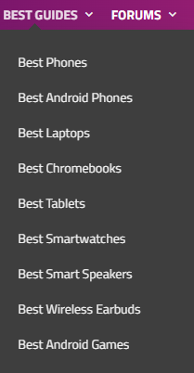

Figure 2: (News)
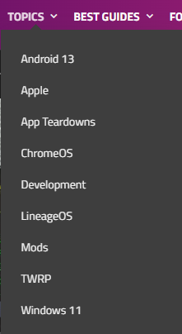

Figure 3: (Topics)

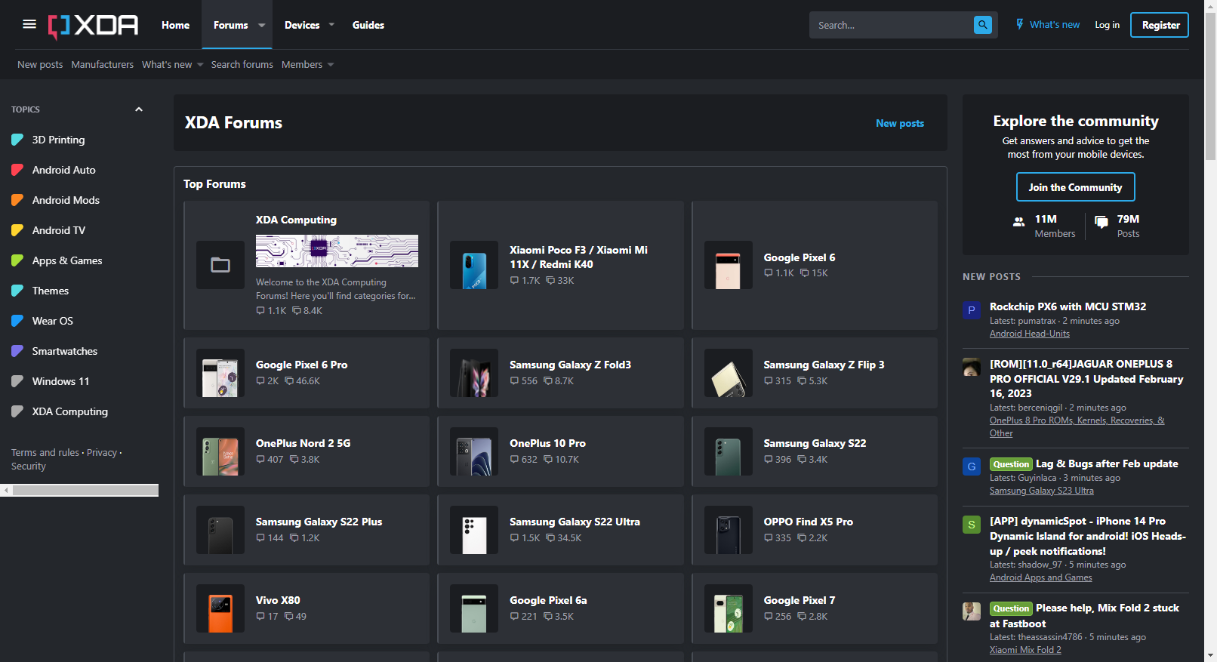

Figure 6: (XDA Forums)
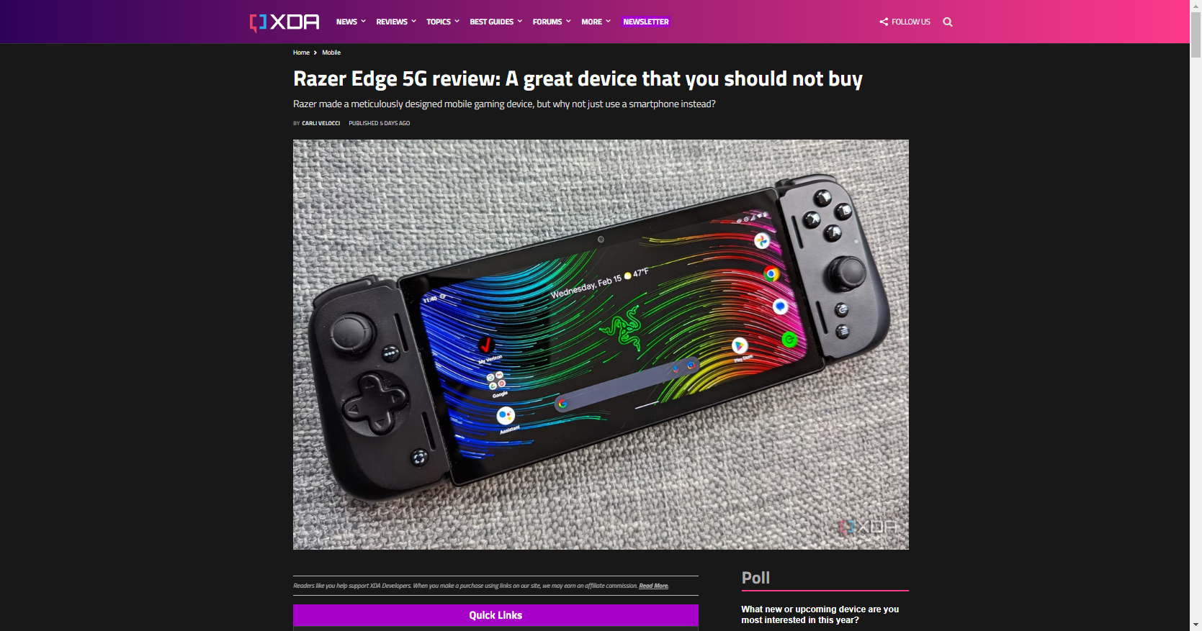

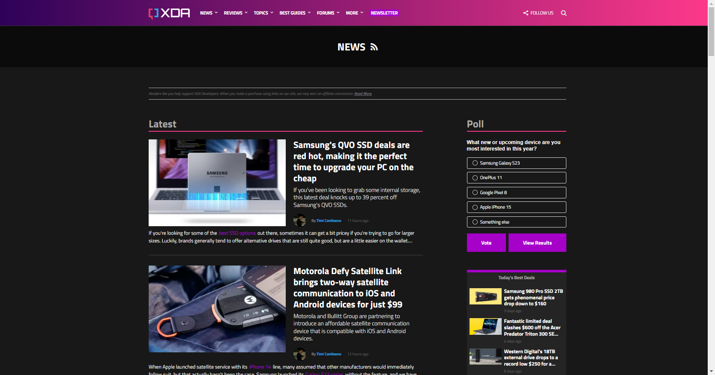
Figure 7: (Mobile Review)

Figure 8: (Latest News)

Visual Design
XDA website has good use grids, columns, headers, typography, white space, and other visual design principles.

Grid Alignment
Both Figure 10 & 11 shows the columns, grid, and the text is left horizontally aligned. Blue is used to show the grid, red is used for columns, and green is used for broken grid. I could not see any gutters in both Figure10 & 11. In figure 10, The middle column is used to show the topic threads, the left column shows a selection of topics that can be chosen, and in the right column users can view the latest posts in xda forums. In figure 11, shows the Review page on the XDA website. The left column shows the latest posts in descending order, while the right column shows a poll widget and Today's Best Deals right below. Whitespace is used quite a lot on this website. Figure 9 is a screenshot without gridlines to help better see where there are white spaces. Both the left and right columns have a lot of whitespace right below, while the middle only has below the Device descriptions.
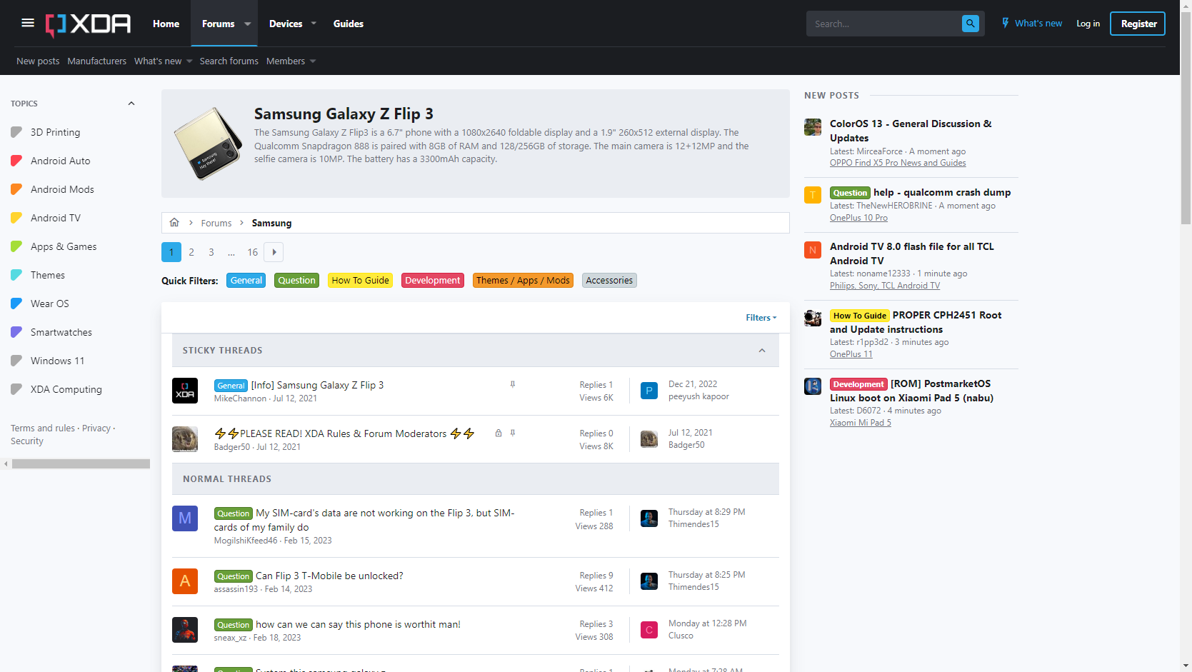
Figure 9: Screenshot without grid to show white space
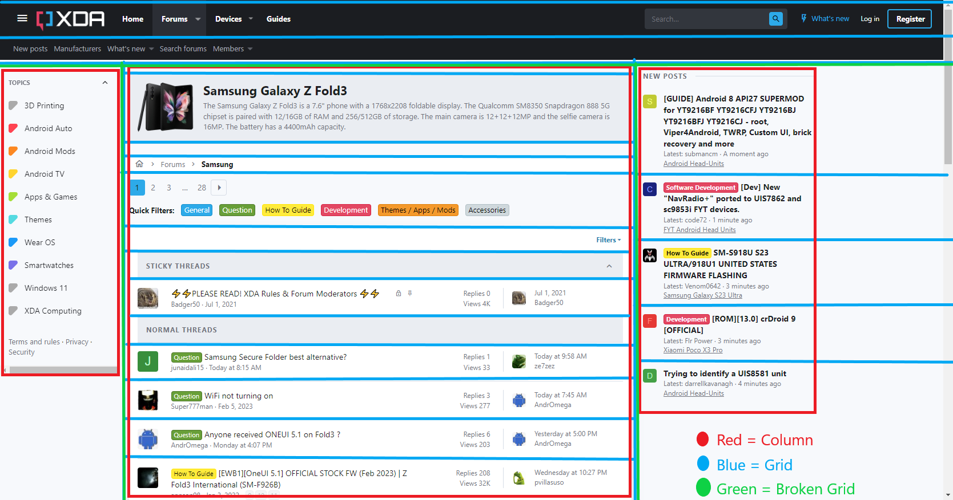Figure 10: Screenshot with lines and labels showing the grid, columns,and broken grid.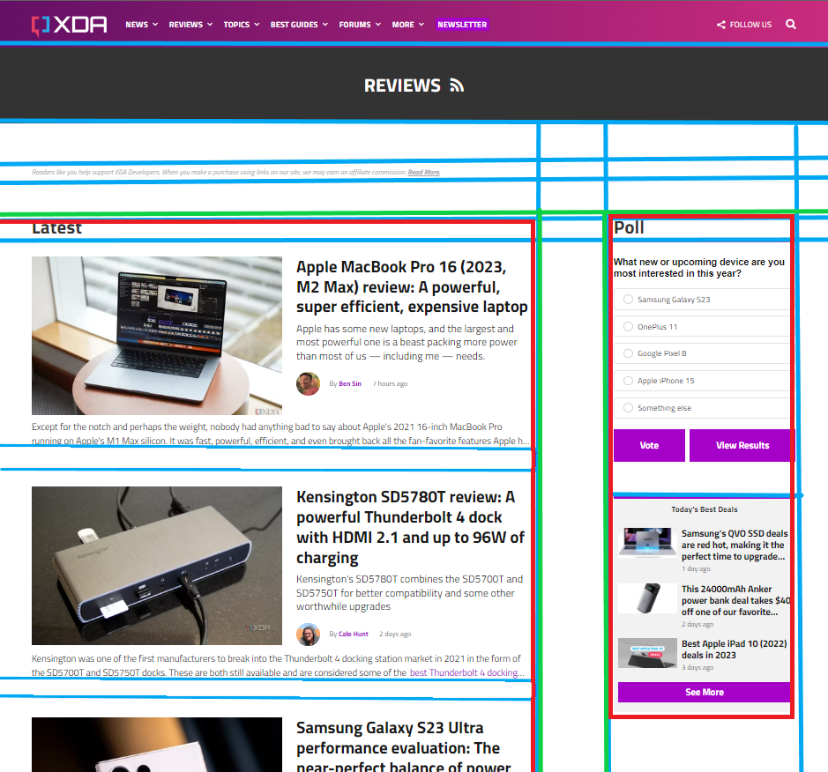
Figure 11: Another screenshot showing the grid, columns,and broken grid

Typeface and Emphasis
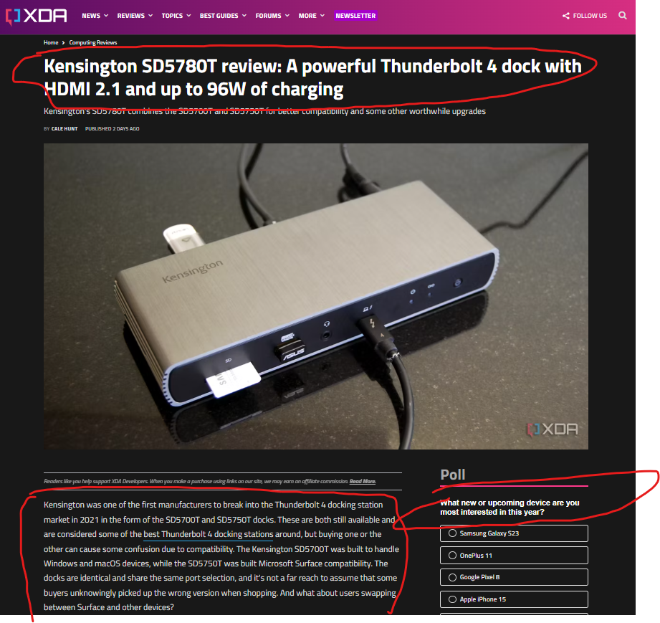
XDA Developers uses only sans serif fonts(Arial, Helvetica) from looking through multiple pages. In figure 12, I have circled in red showing the use of sans serif fonts in the title, body and poll widget. I believe that the font was used effectively, the Titles are in bold large font, and also poll questions were in bold while the answers. Also the latest and poll title were medium boiled font and then for all body text were in regular size.
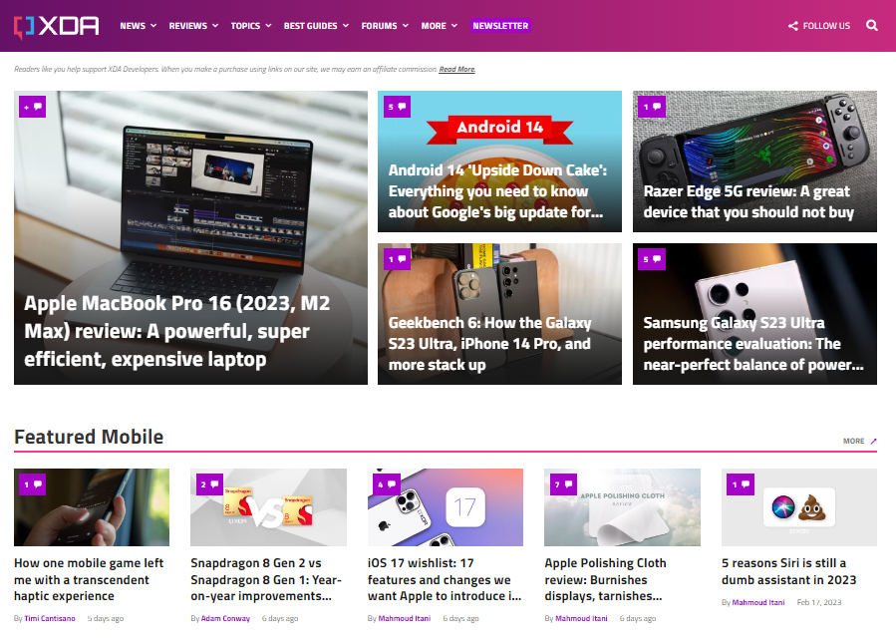

Figure 12: Both Title and body uses sans serif fonts Figure 13: Color

XDA website(Figure 13) uses a simple use of colors, purple, pink-red, black, white, and light gray. The bright purple color is used for buttons, comment icon, and author name, pink-red color used on section break, white color text against the purple color background used on navigation links, and black used on titles and body text & light gray on the poll body text. Also in figure 10, the post categories are colored highlights which is very helpful to understand what category each thread post is about..

(General Question How To Guide Development Themes / Apps / Mods Accessories)

Visual Design Critique and Improvement
Overall the visual design is simple and very effective since it is easy to read on both desktop and mobile devices, by using a single column for reviews makes it simple to read and scroll through while scrolling for an article to read. Since the main use of this website focuses on reading, a simple easy to read font is great for long amounts of reading on computer screens and non intrusive colors use of color is best. For improvements, I think the like in figure 10 where there is quite some white space on left and right side columns can be improved.

Interaction Types and Modalities
The XDA developer website only has one interaction type and some modalities. The interaction type is the most common one, instructing and the modalities are typing and selecting as shown in figure 14 and 15.
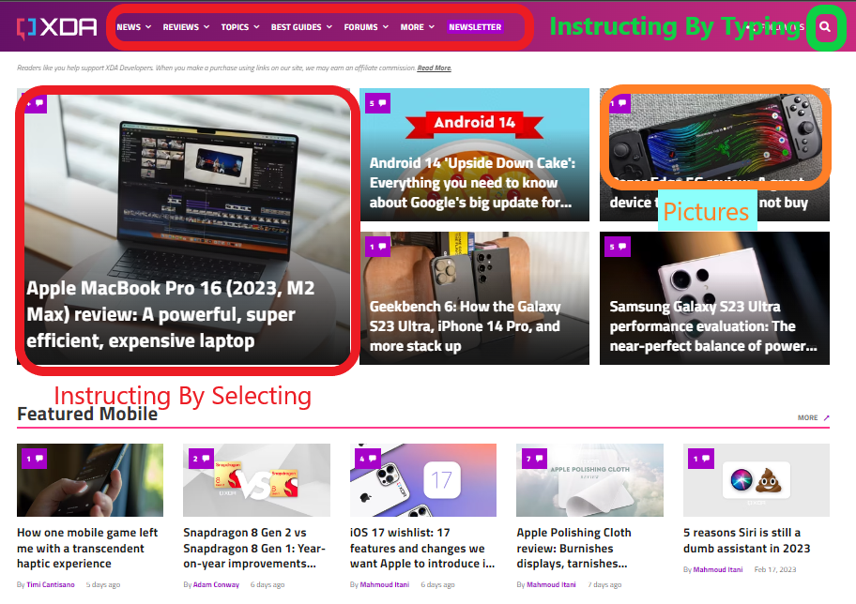
Figure 14: Interaction Types and Modalities
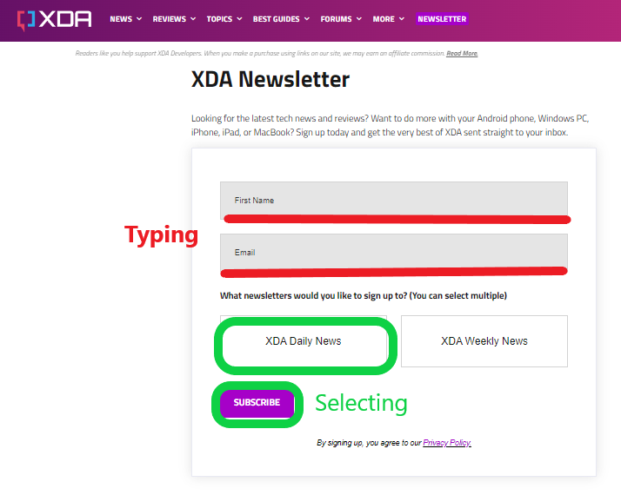
Figure 15: Interaction Types and Modalities 2
The only interaction type, Instructing, is used when users want to type and search for particular topics, for filling in text for signing up for XDA newsletter (figure 15), or for discussion with other users in the XDA forum section page.The modalities, the XDA website uses are WIMP and multimedia. In figure 16, you can see how the WIMP modalities are being used. The blue rectangles show the menus and green shows icons. The WIMP are the navigation menu, contact department menu, an extra footer menu on the right, and also the search icon.
Multimedia is used everywhere in this website especially in the articles of news, reviews, and deals.

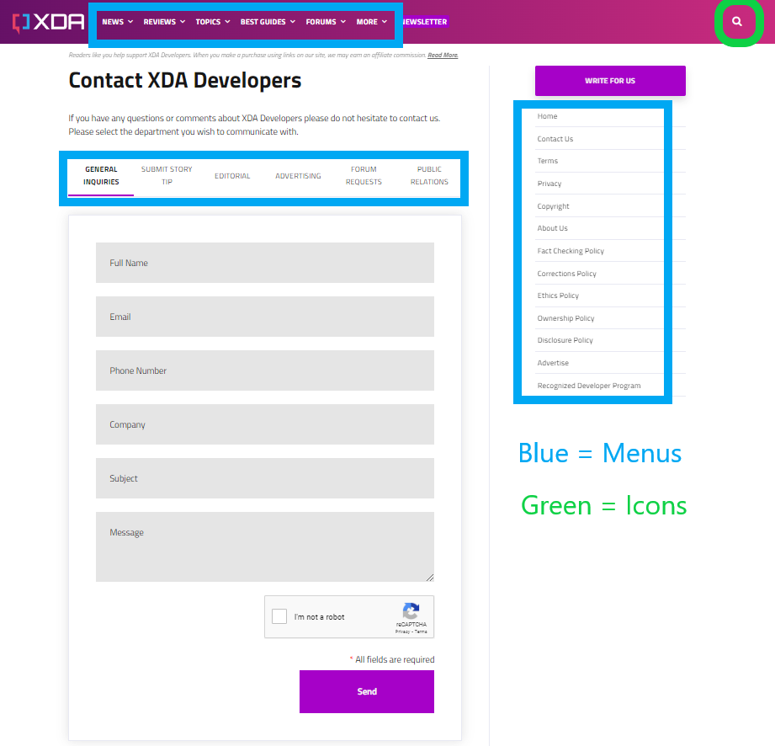
Figure 16: Modalities

Interaction Types and Modalities Critique and Improvement
XDA makes good use of interaction types and modalities, the site mainly focuses on articles for users to read, so having less complicated interactions is better. XDA is missing some features like speech search, filter for search, and a button you can select to go back to the top or bottom of the page.

Affordances, Signifiers and Gulfs
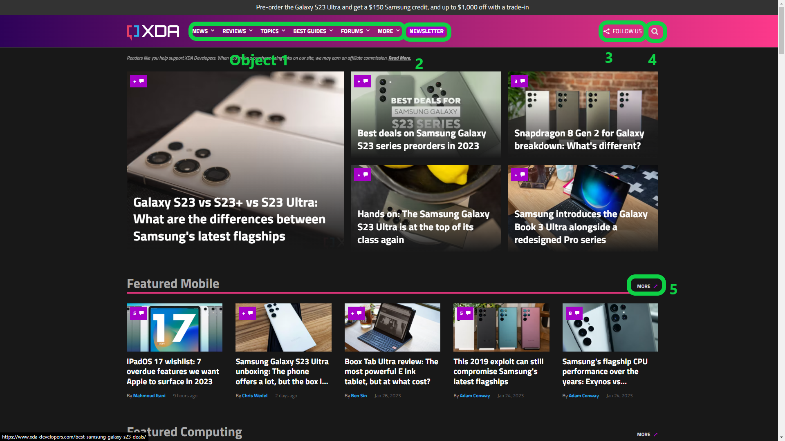
Figure 17: Affordances and Signifiers
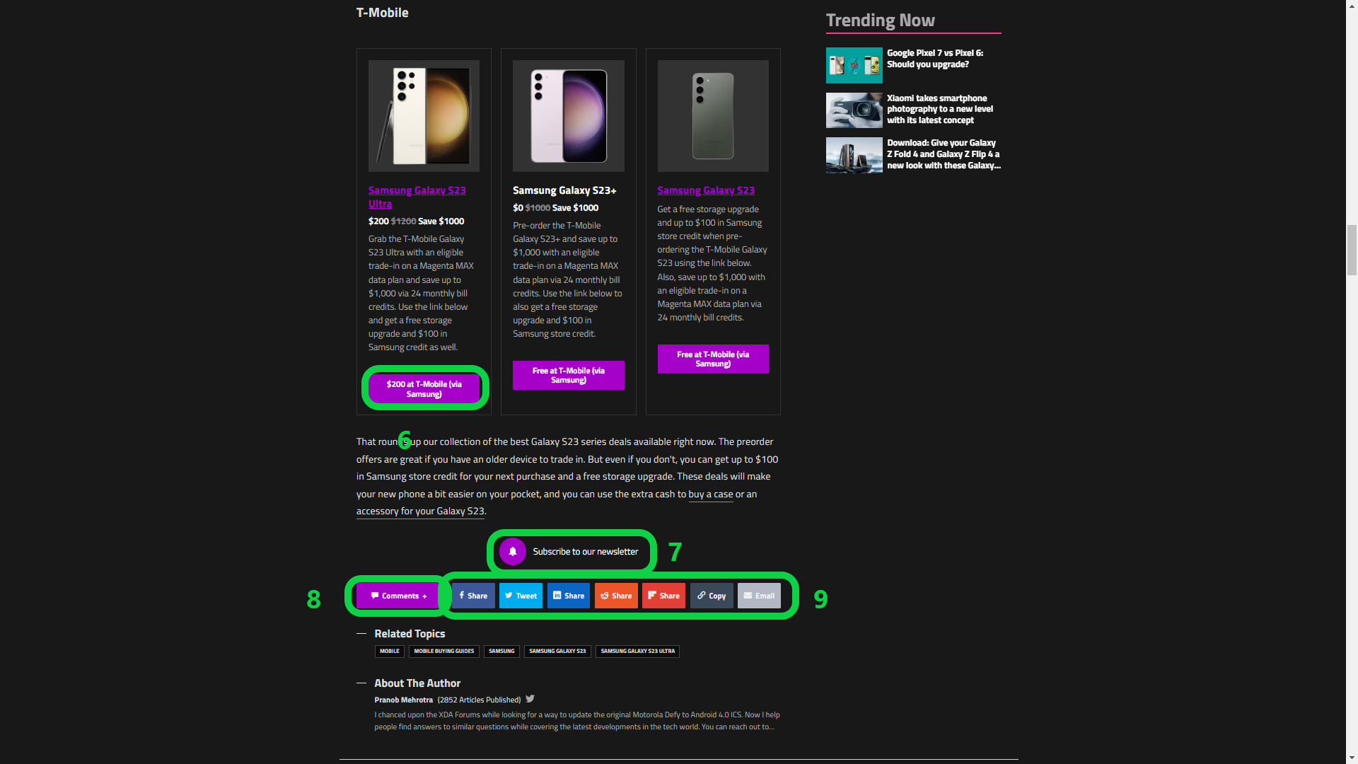
Figure 18: Affordances and Signifiers 2

Affordances and Signifiers
XDA has quite a few affordances and signifiers used overall. In Figure 17 and 18, I have labeled the affordances and signifiers by numbers and can be identified by using the table below.

Affordances and Signifiers Table
Object | Affordance | Signifier
1 | the ability to opens sub navigation menu under word text | signified by ”⌄” symbol right of each text
2 | Navigate to subscribe to xda-developers newspage | signified by word “Newsletter”
3 | Follow on social media buttons | signified by share icon & word “FOLLOW US”
4 | Search bar for website | signified by Search Icon “🔍”
5 | Opens mobile topic page | signified by “↗” icon & word “MORE”
6 | Opens to external page samsung store device page for Samsung Galaxy S23 Ultra | signified by rectangle button & word in inside button “ $200 at T-Mobile (via Samsung)”
7 | Same OBJECT 2 | signified by bell icon & word “Subscribe to our newsletter”
8 | Open comments widget for current page | signified by chat icon & word “Comments”
9 | Same OBJECT 3 | signified by different color & icons button

Gulf of Execution and Evaluation
Below in a table, I have three tasks that users can perform on the XDA website. These three tasks will explain the Gulf of Execution - How does the user know what to do?
and Evaluation - How does the user know what happened after initiating a task?

Gulf of Execution and Evaluation Table
 | Task 1 - Navigation Bar | Task 2 - Search | Task 3 - Articles
Gulf of Execution | User knows what to do cause the dropdown ⌄ symbol besides text. | Search Icon on the right of the navigation bar. | When you hover over the image or Article title text, underlines appear on title text, and cursor changes to click cursor icon implying you can click and open the page.
Gulf of Evaluation | When the cursor hovers over text, the sub menu automatically opens, and by clicking on text in sub-menu, you will navigate to the page the text is linked to. | After clicking the icon the search bar opens with words saying “Search XDA Developers”. | After clicking you will be navigated to the article page.

Affordances, Signifiers, and Gulfs Critique and Improvement
Affordances & signifiers were used efficiently overall throughout the website. The XDA website is easy to navigate and easy to select articles due to the large selection area. I couldn't find any areas that really needed any improvements.

Heuristic Evaluation

Heuristic Evaluation Table
Issue / observation | (Pos or Neg) | Heuristic | Image | Severity (1 -5 point scale, where 5 is very bad)
Cannot reach end of page due to article loading non stop when scrolling to near end of page.  Doesn’t stop until the article limit is reached which is very long. | Neg |  | 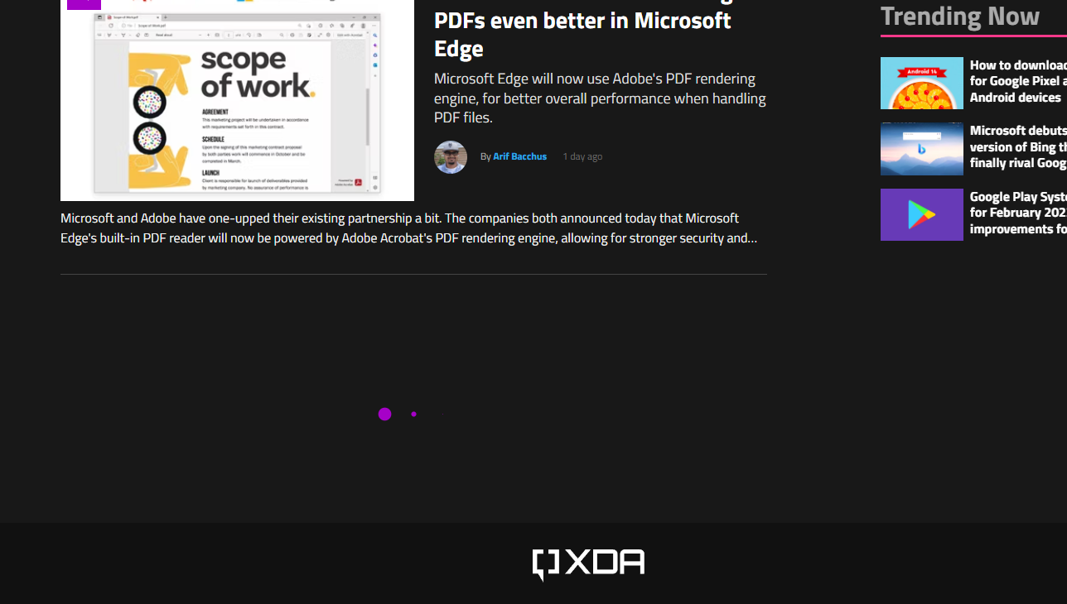 | 4

Analysis

Heuristic Evaluation Critique & Improvement

Conclusion
XDA Developers website is a News/Review/Forum website that is focused on Mobile and Computing Devices, XDA is a well designed website. The web design seems to be better when viewed on mobile devices, but even then the design made it easy to read on both desktop and mobile devices. There are some visual design issues, but mostly small on desktop/laptop and not noticeable/visible when viewed on mobile devices. The website is missing some useful features mentioned in Interaction Types and Modalities Critique and Improvement that will improve user experience, also in Heuristic Evaluation, but overall the design is well-made and easy to understand.

